Multi-Targtes detection using 79 GHz RADAR for Mining Applications

Abderrahim Belissaouia, Safa Saadaouia,

a MASciR, Address, Rabat, Morocco

**Abstract**

Open-pit mining requires the use of heavy and oversized machinery. The presence of such machines constitutes a major challenge for operators and mining machinery safety, which requires long-term solutions. A single accident at a surface mining site can have devastating consequences for personnel, machinery and an entire operation. Their detection will alert operators and thus avoid collision with any obstacle. The short range radar SRR sensor used in the automotive field can be adapted and used in open-pit mining to detect obstacles. In this paper, we propose a novel chirp sequence for a frequency modulated continuous wave (FMCW) radar. Obstacle detection will be established in occurrence of AWGN noise and impulsive noise at several levels to study the robustness of our system.

*Keywords: RADAR, FMCW, Detection, IOT, Noise, SRR, Mining.*

**1. Introduction**

Interest in autonomous vehicles has grown rapidly in recent years. These vehicles, using advanced driver assistance features such as adaptive cruise control, forward collision warning and lane keeping assistance, are already widely deployed in automobiles [1]. Extending these technologies to the mining sector has proven to be essential. Visibility in such an environment, whether underground or open-pit mining, is reduced causing many accidents. The large size of the excavation machines leads to the presence of blind spots on all sides of a vehicle. In addition, dust, dirt and debris raised during excavation can reduce visibility. Weather conditions, such as wind, rain and snow, also raise significant issues. To overcome these challenges, obstacle or target detection sensors can be placed at the front and rear of each mining vehicle. In general, for autonomous vehicles, several types of sensors can be used such as cameras, Lidar or radar. Radar sensors are the most widely used because, unlike other sensors, they provide accurate information on the distance and speed of neighboring vehicles in all weather conditions [2]. Furthermore, for a dusty mining environment, radar sensors are more adapted and more robust.

The main objective of a radar system is the detection and localization of an object by means of a return signal which is the signal reflected on the target. FMCW (Frequency Modulation Continuous Wave) radar has been used worldwide as an effective method of automotive radar. It offers several advantages such as short range object detection, easy implementation, low power consumption, simple and low cost miniaturized system design. In particular, for the detection of close targets, FMCW radar is an alternative to pulse radar because it is not limited by the transmission pulse width and the switching time between transmission and reception. Besides the modulation technique used, in order to increase the accuracy of target detection, radar systems must operate at bandwidths greater than the currently used narrow-band frequency ranges of 24 GHz and 76 GHz. The use of wide bandwidths and the limitation of high powers will result in higher resolution and better target discrimination. Higher frequency radar systems tend to provide better results because they are more reliable and accurate. In addition to a better ability to distinguish objects, the 77-81 GHz frequency range (79 GHz band) also offers other advantages, including the fact that radars can be much smaller, the same technology can be used for all applications, and the risk of mutual interference is low because the required transmit power is lower. The use of a 4 GHz wide band, available around 79 GHz, provides high spatial resolution and greatly increases the ability to distinguish objects. Initially reserved for military use, the 79 GHz band for short-range radar was authorized by the European Commission in 2004 and governed by the ETSI (European Telecommunications Standards Institute) standard. Vehicle radars transmitting in the 79 GHz band are not subject to time or other operational limitations. The 79GHz band radar which is used for a middle and short range is required to have high resolution and wide detection-angle performance.

In this paper, we propose a new multi-target detection algorithm for FMCW radar to reduce the ghost target.

**2. FMCW RADAR System Description**

.....However, this radar gives rise to ambiguities in the treatment of range-velocity in multi-target situations [4]. Especially, the separation of ranges and velocities for each target with a high relative velocity. Or, identification of the correct combinations of beat frequencies for multiple targets.

In the case of a multi-target situation, multiple up and down beat frequencies are detected. The combined processing of several beat frequencies results in the creation of ”Ghost targets” and thus degrades the performance of the radar. To solve this problem, mainly two detection techniques are used [5,6]. The first method is based on sending fast ramp trains [8], as shown in Figure 1. In this method, a two-step FFT (Fast Fourier Transform) is used to detect the distance and speed of the target. Since the measurement of the movement duration time is very short compared to the target distance, the detected Doppler shift of the detected beat frequency may be negligible. Therefore, the range is detected in the 1st FFT at every pulse repetition interval. This method is very efficient, but it requires a large computational effort due to the generation of many ramps. The second approach [8] uses slow ramps with different slopes, as shown in Figure 2. In this approach, the computation is lower compared to the first method. However, as this method is an extended version of the typical FMCW technique, an additional algorithm that combines the beat frequencies and the ghost target cancellation technique is still needed.

**2.1. FMCW fonctional bloc diagram**

The functioning principle of the frequency-modulated continuous wave RADAR is shown in the figure below:

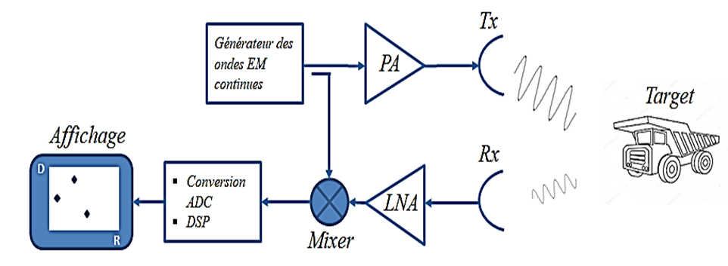

Figure 1: Bloc Diagram (to be modified)

The main circuits of the Mining RADAR operate in the millimeter band [76-81] GHz. The manufacturers of anti-collision and driver assistance RADARs introduced the concept of frequency modulation on continuous EM waves to overcome the difficulty of measuring the time of transmission-reception of the signal. The waveform design for the RADAR FMCW is based on the requirements of the RADAR system in terms of resolution, accuracy and power [14]. The performance in terms of detection of a frequency-modulated continuous wave RADAR system depends on the choice of the emitted waveform. For an anti-collision RADAR, detection and localization must be performed in the case of multiple targets [15].

To generate frequency modulated waves, several techniques have been proposed. The most widely used form of modulation is the linear form (ramp) that relates frequency and time, commonly called Chirp [5]. There is also the triangular modulation or double triangular modulation form called 'double FMCW'. This second triangular signal, allows to correct the calculation error made during the calculation based on single FMCW modulation (chirp, triangular modulation).

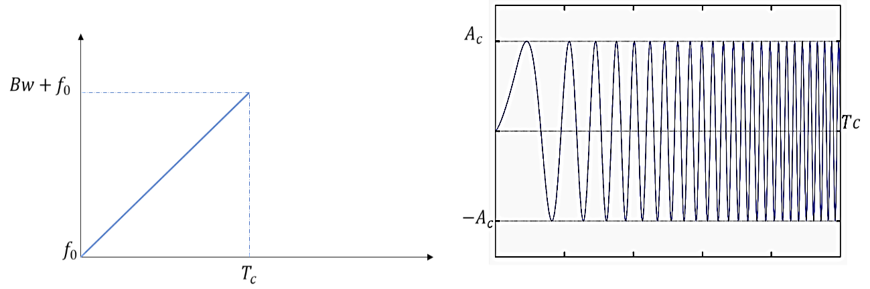For this paper, we opted for a linear shape “Chirp” as shown in the figure below:

Figure 2 : Chirp Waveform

This waveform is based on the generation of a linear function of frequency and time and the transmitted signal $x\left(t\right)$ is expressed as:

$$x\left(t\right)=A_{c}cos\left[2π\left(f_{0}t+\frac{Bw}{2T_{c}}t^{2}\right)\right]$$

Where: $A_{c}$ is the amplitude of the signal, $f_{0}$ is the transmitter frequency at $t=0$, $Bw$ corresponds to chirp bandwith and $Tc$ is the chirp period.

**2.2. Propagation medium**

Radar technology is used in a mining environment to provide assistance to drivers to avoid collision with potential obstacles. Using Intelligent Collision Avoidance Radar on machinery makes vehicles self-sufficient in the long term. Nevertheless, the use of such wireless communication technology in the mine may be sensitive to the harsh propagation conditions associated with the presence of dense dust clouds and also to the dimensions of the vehicles. Therefore, it is necessary to test the performance of the Radar in a noisy environment.

The wireless propagation is modeled as a multipath channel with noise addition at the receiver. For this work, only the influence of noise on signal detection will be presented. Usually, in information theory additive white Gaussian noise AWGN is the elementary noise model used to illustrate many random processes that occur in nature. Its power is uniform over the entire frequency bandwidth of the system and follows a normal distribution with an average value of zero.

For more realistic modelling, the mining environment is considered to be a complex industrial environment. According to several previous studies, the additive noise in this environment is considered to be AWGN noise $w\left(t\right)$ plus impulsive noise $i\left(t\right)$. In the open pit mine, impulsive noise is generated by the presence of heavy excavating machinery, which causes strong vibrations and high noise levels. It is modelled according to a Gaussian distribution of zero mean and a high variance [réf].

Probability density functions for both $w\left(t\right)$ and $i\left(t\right)$ are respectively:

$$P\left[w\left(t\right)\right]=\frac{1}{\sqrt{2πσ^{2}}}exp\left[-\frac{{w(t)}^{2}}{2σ^{2}}\right]$$

$$P\left[i\left(t\right)\right]=\frac{1}{\sqrt{2πRσ^{2}}}exp\left[-\frac{{i(t)}^{2}}{2{Rσ}^{2}}\right]$$

With $R≥1$ is a scaling constant of impulse noise amplitude. The noise intensity increases according to this value.

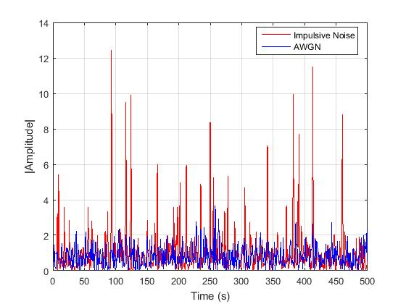

Figure 3: AWGN and Impulsive noise with R=50

**2.3. FMCW RADAR Detection**

The received signal is expressed by:

$$y\left(t\right)=x\left(t\right)+n\left(t\right)$$

Where noise $n\left(t\right)$ can be either equal to $w\left(t\right)$ or $i\left(t\right)$.

The detection and/or localization of a target in a mining environment by a millimeter RADAR, is based on the estimation of its distance and angle. Radio frequency receivers are based on a set of metrics to provide the position of the target by estimating its angle. In general, these metrics are based either on the measurement of two angles (triangulation), or on the measurement of distances based on the measurement of time, or on the measurement of received power using accurate knowledge of the propagation channel.

Add figure with Detection steps: LPF 🡪 Beat Frequency Signal 🡪 FFT

The RADAR transmits an FMCW signal. Part of this signal will be reflected and returned to the RADAR when it meets a fixed or moving object. After mixing received and transmitted signals and applying low-pass filtering, the beat signal called beat frequency signal, is obtained. The time shift between the received and transmitted signal will be used to calculate the target distance. Regarding the frequency shift generated, if it is zero it means that the speed of the target is zero so this target is fixed. Otherwise, for a moving target, the Doppler frequency is added and allows the target speed to be measured.

For a better illustration, after mixing the signals and applying the low-pass filter, a video signal is extracted. Then, an FFT is applied to represent this video signal in frequency domain. This representation shows peaks in the video signal. They correspond to the beat frequencies. Distance and speed can be calculated from these frequencies.

**3. Discussion**

In this section, simulation results for multi-target radar detection in the presence of noise will be presented and discussed.

Parameters (frequency, nb of targets, Bandwith… – and platform for simulations

|  |  |
| --- | --- |
| *Figure 4 Transmitted Chirp* | *Figure 5 Received Signal* |

After applying the low-pass filter (type?) and the FFT to the video signal, the spectral representation of the power versus the frequencies of the mixed signal shows the presence of beat frequencies. Figures 6, 7 and 8 show the spectrum of the mixed signal in the presence of AWGN noise at 0, 10 and 20 dB respectively.

|  |  |
| --- | --- |
| Figure 6: Mixed signal Spectrum at SNR = 0dB | Figure 7: Mixed signal Spectrum at SNR = 10dB |
| Figure 8: Mixed signal Spectrum at SNR = 20dB |  |